Data Leakage in Online Social Networks
Institutional Affiliation
Students Name
Date

Introduction
The rate of increment of using social networks cannot be denied globally. Many people have shifted to using the internet in so many ways the major reason being communication. Emerging trends like cloud computing being a great aid. Examples of websites offering internet services include Myspace, Twitter and Facebook among others which enable people to communicate regardless of location obstacles. People share sensitive information of themselves trusting the services operator and the other party to maintain high levels of secrecy with the contents of the information. The main concern is how secure is this information. Studies have depicted security problems facing the networking world. It is possible for data to be obtained from a user’s profile without their consent, for example, in the digital forensics world where investigators rely on Online Social Networks (OSN) to obtain information about criminals providing the evidence that they need to conduct their duties [1] This clearly means the content in the profiles are not confidential as they are supposed to be and can be accessed by the wrong person.
Putting data of millions of users in one domain leaves users in a vulnerable situation of disclosure of their information without their knowledge. In addition, providers must look for other ways of generating income as a result of offering free services. This explains why, for example the government and the digital forensics department have a way of accessing criminal profiles without a problem. It is expected that individual’s become cautious of the level of confidentiality that internet providers offer and according to a survey with a samples size of 2253 adults done, 65 percent of adults had changed their settings to reduce what content they expose to others [2]. Others erased profile comments and a number showed their concern on what they had posted. Users of OSN have exposed themselves to threats in terms of their private life and their security which are classified mainly into four categories. Classic threats are the first ones which endanger both the active and the dormant user of social network. Commonly referred to as phishing, Cross-Site Scripting (XSS), Spam and Malware. These have become an issue for some time because of the structure of OSN and can be spread at a high speed [3]. Modern threats follow which jeopardize the environment and use the infrastructure of the OSN to threaten the user. Information leakage, Inference Attacks and Identity Clone Attacks are some examples falling under this category. Mostly target the personal information of the user and information belonging to their friends. Combination threats are the third where attackers merge different types of attacks to form a fatal attack. Attackers today can join both modern and classical threats to form a catastrophic attack which has a significant effect implying that recovering from this type of attack will require effort. Children using OSN are also affected by these threats and fall under the fourth category. Online Predators are the main issue when it comes to children whose target is majorly based on exploiting the children sexually either through contact or exposing harmful content to the children [4]. Since OSN is attached and has become a way of life for many people, it is important to come up with ways of reducing privacy issues.
IEEE COMMUNICATION SURVEYS RIALS, VOL. 16, AND TUTORIALS. 4, FOURTH QUARTER 2014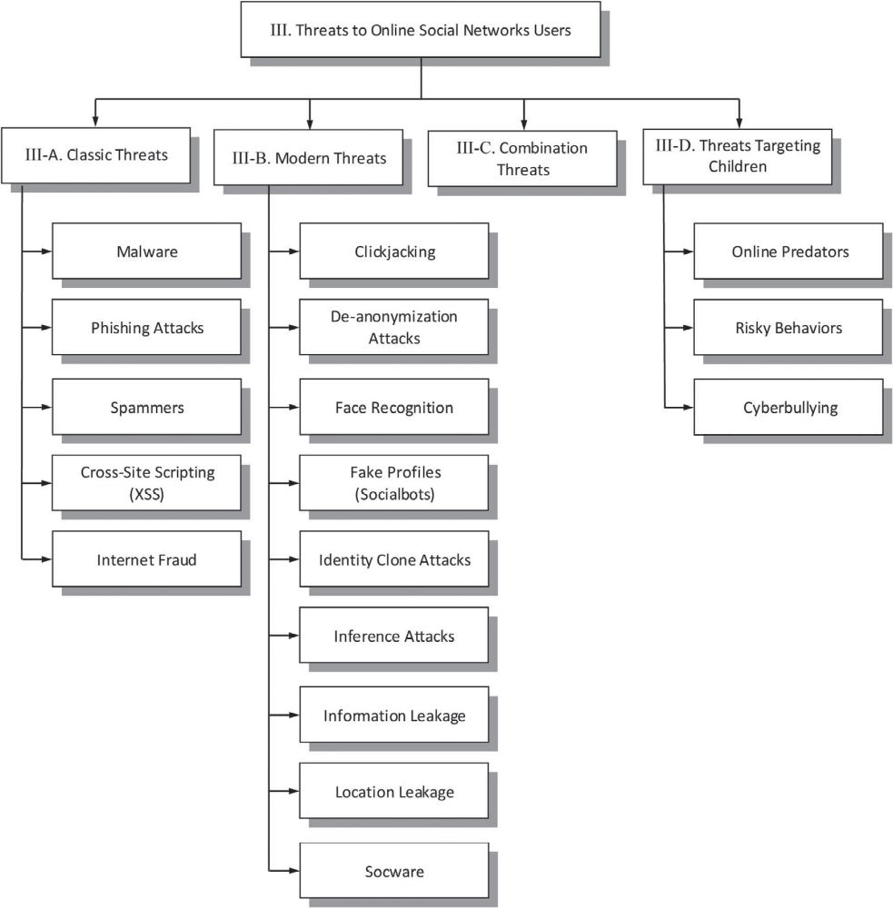 Fig. 2. Threats to online social network users
Authentication Mechanisms such as CAPTCHA, multi-factor authentication, photos-of-friends identification and even requesting visual of an ID from the government have been put in place to deal with these threat problems. These are used as a way of verification that you are the owner of the account when trying to access it. [5]. Recently, two- factor mechanism authentication was adopted by Twitter where the user is required to verify a code sent to their device even after using a password to log in. The significance of the mechanism is that it prevents malicious users to hack and exploit any account. Settings meant to secure and maintain confidentiality are emphasized by many OSN operators. A good illustration would be using Google+ where private settings are customized and users are allowed to create groups according to an area of relation. [6]. For example we have friends group where persons of interest are allowed to share information according to their choice guided by their connections. These enables users to protect their information by posting relevant materials to marching groups. Another example is Facebook where users have an option to select who to access any information that they post. Extra configurations of security are also taken into consideration by some OSNs where user s able to secure active browsing, get notifications to log in and take other safe precautions to protect their personal information. [5].
,
Vis-`a-Vis is a framework for enhancing sensitivity of data from OSN which has the ability to operate with the existing networks and is designed as a federation of Virtual Individual Servers (VIS). This VIS works in a cloud computing platform that is normally charged, for example. Rack space cloud Servers. They protect user’s information and decline other parties who request the information. [7]. in many instances, it is easier to find a user trying to forge a number of identities so as to get access to other people’s files. Some OSN providers have tried using governmental documents for registration which makes forging difficult. However, this is not enough to deal with the problem. A better way of approaching this is to use relationships based on life relations to identify the user. Although Online Social graphs can be trusted with a high rate to design a mechanism of defence, personal information can be misused. Therefore, the main objective is to find a way of protecting the said graphs.
One solution to curb the problem is to use qualitative properties to lessen the conflicts in life networks. [7].
As solutions to protect user’s information are coming up, better ways to collect this information are also been upgraded. For instance digital forensics is traditionally based on analysing system files, logging into files or capturing networking traffic (4). Advanced approaches of getting files from social networks are a necessity although little effort is put in to develop the new ways. Custom Web Crawlers is one finding of the said research an approach with a number of limitations. It is an expensive method due to HTTP traffic and may also suffer being blocked by websites especially if they are causing extremely high traffic preventing access to more information. Websites tend to change such that one is not able to predict when the change occurs. To add to that maintenance of high capacity is required to cater for dynamic content like the JavaScript. [7].

A data collection method from social networks is focused to provide solutions to the above problems using an approach which is based on a hybrid system that utilizes an OSN third party application combined with an automated web browser. [6]. this system can be used efficiently to collect data based on social snapshots and information from social networks. The main factors contributing to this are:
1. A prototype application whose main aim was Facebook which was implemented and released under an open source license [1].
2. Evaluation on an experiment based on real world test was performed with volunteers and results were shown [6].
3. Ways to gather data efficiently from OSN that may serve as criminal evidence with tools that enable linkage between evidence collected online and artefacts from traditional forensics [7].

Crime rates involving computer technology have increased in recent times making Digital Forensics a centre of attraction. Evidence is retracted from social networks that help law enforcers to find justice for committed crimes [2]. Advanced methods have been adopted which render traditional methods which involved access to tangible computer parts not useful. A techno-Savvy is among the new methods available which uses encryption and stores files without necessarily utilizing a hard disk [1]. After the exercise is conducted, no trace of the examiner as it disappears immediately the computer closes. Again a problem arises due to many people communicating globally which qualifies OSNs as potential platforms for crime scenes investigations. These is not a guarantee that valid information or even any will be available to provide evidence against a particular suspect. In fact a court might require a company to provide information of a suspect which may bare no fruits as details on the server are only restricted to the server.
An application from Digital Forensics provides an investigator with the ability to snapshot a network account which includes meta-information such as exact time snaps are not accessible to the user through the interface of the application website. Since information in OSNs is broad, a proposal of a combination of an automated web browser and a third party application is considered. The application is set up using the user’s confidential details. The third party application is customized and is introduced to the target account on a temporary basis [8] which gathers the data of the user. Information not included in the third party application is then obtained after utilizing traditional web crawling techniques. [2].The behaviour of the human user of OSN is stimulated using a standard web browser reducing blocking risks from networking sites. [2]
The details of the target user serve as an initialization of the snapshot social client where the automated browser is started with the authentication mechanism. Social snapshot mechanism is then added by the automated browser to the profile of the users being targeted and the API secret is sent to the Application server. The response is received from the social snapshot application containing the list of contact of the target. Exact web pages are requested by the automated web browser together with their list of contact. Crawler data that has been received is stored as the social snapshot application gets information that is personal through OSN API [4]. Social data gathered through the third party application is lastly deposited in the social snapshot application server. The steps above illustrate the framework of the social snapshot. Accessing information from a user’s account, social snapshot uses starting tokens from authentication based on scenarios from digital forensics which are consent, social network hijacking and image extraction from forensics. [5].
Experiences that we undergo can be termed as the perpetuators of inventions and innovations that address the problems we have. From this data, it is clear that OSN users’ privacy is so much needed. While reviewing the data at hand, existing privacy solutions have been singled out identifying the main strengths as well as their shortcomings thus helping researchers to be able to customize existing structures to address the problem. In short, this research helps in the development of techniques that effectively educate OSN users to be much aware of the existing threats. This can help them develop privacy solutions to their social networks; for instance, devising mobile self-configurations for their social apps – Semantics-based Mobile Social Network (SMSN) is an excellent mobile app that addresses security issues. This is how solutions are sought to help reduce/curb data leakage problems over social sites.
Concluding words
Social media has become part of our daily lives. This is one of the reason why data leakage has been on the rise. This topic has been researched over and over and recommendations passed on which do not seem to be effective. Every other time, a research tries to improve on the previous researches. It is evident that data leakage is a problem facing the social network wold due to vast usage of internet globally. Data security and privacy has been a problem for some time but with the techniques discussed above, solutions to curb the problem are put into place. Some of the recommendations that this research reaches at are; users’ education tandem to the online threats to keep them in a situation of self-awareness hence helping resolute the problem, evaluation of any new security scheme to establish synergy with useful technologies and the right algorithms, among others.

References
[1]. Sba-Research.Org, 2018, https://www.sba-research.org/wp-content/uploads/publications/social_snapshots_preprint.pdf. Accessed 18 Oct 2018.

[2]. Privacy And Security For Online Social Networks: Challenges And Opportunities - IEEE Journals & Magazine". Ieeexplore.Ieee.Org, 2018, http://ieeexplore.ieee.org/document/5510913/. Accessed 18 Oct 2018.
[3] "Fake Profiles Detection On Online Social Networks". Escience Institute, 2018, https://escience.washington.edu/fake-profiles-detection-on-online-social-networks/. Accessed 18 Oct 2018.
[4]. sers.cs.duke.edu, 2018. [Online]. Available: https://users.cs.duke.edu/~lpcox/shakimov-comsnets11.pdf. [Accessed: 18- Oct- 2018].
[5]. S. Torabi, K. Beznosov, "Privacy aspects of health related information sharing in online social networks", USENIX Workshop Health Information Technologies, 2013, [online] Available: https://www.usenix.org/conference/healthtech13/workshop-program/present
[6]. A. Acquisti, R. Gross, F. Stutzman, "Faces of facebook: Privacy in the age of augmented reality", Proc. BlackHat USA, pp. 1-56, 2011
[7]. Q. Cao, M. Sirivianos, X. Yang, T. Pregueiro, "Aiding the detection of fake accounts in large scale social online services", Proc. 9th USENIX Conf. NSDI, pp. 15, 2012, [online] Available: http://dl.acm.org/citation.cfm?id=2228298.2228319

